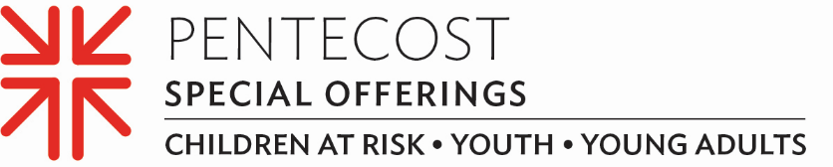

Minute for Mission
Pentecost Offering Helps Young People Challenge the World’s Injustices

Yuriko Beltran wants to change the world — which is exactly why the 23-year-old entered the PC(USA)’s Young Adult Volunteer (YAV) program.

“I like the fact that I actively contribute to change, which is what the YAV program mainly seeks to accomplish,” she said.

The YAV program is an ecumenical, faith-based year of service in sites across the U.S. and around the world that has been changing the lives of young people ages 19–30 for nearly three decades. The YAV experience emphasizes living in intentional Christian community, spiritual formation and vocational discernment. Yuriko is currently serving at the Peru YAV site, managed by mission co-worker and site coordinator Jenny Valles.

“This is a program where young people can experience dramatic transformation in their lives through their experiences serving alongside our global partners,” said Jenny. “To be able to accompany the young adults in a personal way through these experiences is such a privilege and makes this ministry both fun and meaningful.”

Jenny shares, “The focus of the YAV program in Peru has always been addressing systemic poverty and racism. Many of our partners have been working on these issues for years at the local, national and international levels. Our volunteers have an orientation and retreats to further address these issues along with others specific to the context of Peru such as rights and challenges of the LGBTQ+ community, Machismo in Peru, political context and economy of Peru, climate change, personal self-care and intercultural challenges.”

Yuriko states, “I believe that being able to hear firsthand the testimonies of people who face a certain problem, and the goals they set to generate positive changes, makes me identify and empathize with people and their needs,” said Yuriko. “This motivates me.”

Gifts to the Pentecost Offering support the YAV program, and also the Office of Presbyterian Youth and Triennium and the “Educate a Child, Transform the World” national initiative. Forty percent of the Offering is retained by congregations just like ours for our own ministries like (DESCRIBE HOW YOU USE, OR WILL USE, YOUR 40%). The remaining 60% is used at the Presbyterian Mission Agency level.

“If we all had the opportunity to have experiences like the YAV program offers, I believe that we would all be more empathetic, more just and more supportive of one other,” says Jenny. “I invite potential donors to walk hand in hand with us through their support of Young Adult Volunteers. Their prayers and donations transform lives not just for a year but for a lifetime.”

Many churches receive the Offering on Pentecost Sunday, which this year falls on May 28. Please give generously — for when we all do a little, it adds up to a lot.

Let us pray ~
Faithful God, we give thanks for the YAV program and for other opportunities that offer renewal and hope and that guide young people in Christian formation. Thank you for communities that transform us and our world. Amen.

