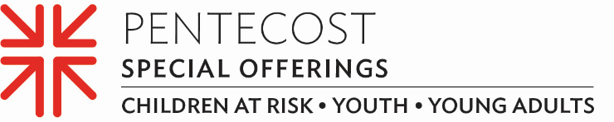

Minute for Mission
Building a Life of Faith – Living a Life Through Faith
The branches of their family trees are filled with Presbyterian pastors and elders, so it’s no wonder that Akilah Hyrams and Noah Westfall — both alums of the PC(USA)’s Youth Adult Volunteer or YAV program — have lives rooted in their faith-building experiences.
The YAV program is an ecumenical, faith-based year of service for young people ages 19–30 in sites across the United States and around the world. YAVs accompany local agencies working to address root causes of poverty and reconciliation. Alongside this work, volunteers explore the meaning of their Christian faith and accountability to their neighbors in the community with peers and mentors.
Akilah spent her 2016–17 YAV year serving in the Philippines. She expressed interest in pursuing a medical career and the YAV site coordinator was able to customize her experience based on her vocational aspirations and interests.
“Volunteering in health clinics was an amazing opportunity which I am so grateful for,” she said. “Working in the clinics solidified for me that medicine was where I was being led.”

Noah spent his 2018–19 YAV year serving Texas Impact, an interfaith organization that works on issues that impact the most vulnerable and helps people move their faith community from charity to justice. Working at Texas Impact was excellent preparation for his current role as program coordinator for the Primary Care Collaborative, a Washington, D.C.-based health-care advocacy nonprofit that advances comprehensive primary care to improve health and health care for patients and their families.
“The YAV program walks alongside young adults like Noah and Akilah to help with their vocational discernment in areas such as race, poverty and church vitality, the three foci of Matthew 25,” said Destini Hodges, the YAV program coordinator. “Learning the complexities of structural racism and systemic poverty through a Christian faith perspective allows them to develop skills and apply them wherever the future calls.”
The YAV program is supported, in part, through the Pentecost Offering. The offering also supports the Youth Triennium and the “Educate a Child, Transform the World” national initiative. Forty percent of the offering is retained by individual congregations like ours for local ministries with young people, while the remaining 60% is used to support children-at-risk, youth and young adults through ministries of the Presbyterian Mission Agency. (TALK ABOUT HOW YOU USE THE OFFERING IN YOUR COMMUNITY)
When it comes to what our gifts to the Pentecost Offering can do, perhaps Akilah says it best. “When you donate, you’re supporting someone through a life-changing experience, which looks different for everyone,” Akilah said. “These experiences open our eyes and broaden our horizons. Thank you for any support you can give. You’ll never know how much it truly means to each and every one of us!”

Let us pray ~
Great physician, heal our communities by your grace, and raise up leaders in every field, who seek your hope, wholeness and well-being for this, your world. Amen.

