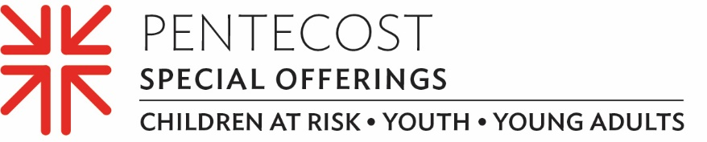

A world away, yet connected through faith
Just when most young people were beginning to imagine what nontraditional instruction might look like during COVID-19, Sami Han took things a step farther — a big step farther.
She moved to South Korea with her parents.
When the 16-year-old’s parents, the Revs. Myung Sung “Martin” Han and Jieun Kim Han, accepted the call to serve as regional liaisons for East Asia in World Mission for the Presbyterian Mission Agency (PMA), Sami left everything she knew in the U.S. behind — church, school, her two older brothers, her friends — but the one thing she didn’t leave behind was her deeply felt connectedness to her church.
Sami enjoyed developing, planning and leading a worship service as a member of the youth group at New Goshen Presbyterian Church in Kentucky, where her father most recently served as transitional pastor before the family relocated to Seoul. She also participated in many other ministries, and even volunteered at two of the PC(USA)’s national Big Tent events, first in Indianapolis in 2011 and then in Louisville in 2013.
It is through young Presbyterians like Sami that we are building the Church, together. Gifts to the Pentecost Offering help our youth build a strong foundation of faith that will last a lifetime. Our gifts support the Presbyterian Youth Triennium, Young Adult Volunteer Program and the “Educate a Child, Transform the World” national initiative. Sami says she is already setting her sights on joining teens from all over the world who will attend the 2022 Youth Triennium (INCLUDING FROM OUR CHURCH).
Although the Pentecost Offering may be taken anytime, most congregations receive it on Pentecost Sunday. Sixty percent of the offering is used to support children-at-risk, youth and young adults through ministries of the Presbyterian Mission Agency while 40% of the offering is retained by our congregation for local ministries with our youth and young adults.
Supporting young Presbyterians like Sami is what the Pentecost Offering is really all about, according to Gina Yeager-Buckley, Mission Associate for Formation including the Presbyterian Youth Triennium and other youth-focused ministries.
“It’s such a joyful, positive and formative thing to invest in as we continue to watch young people like Sami take their next steps into leadership in the church and in their communities,” she said. “To me, the Pentecost Offering witnesses to a church — from every level, local to national — that is excited in lifting up its young people and connecting them. You’ve got a healthier church. You’ve got a vital church. That’s what I believe in.”
That’s what we all believe in, too. And here is something else we believe … when we all do a little, it adds up to a lot. Please give generously to the Pentecost Offering.
Let us pray ~
Pentecost Spirit, inspire our faith, again, through the young people in our Church. Let the bright faith they share light your fire in all. Amen.

