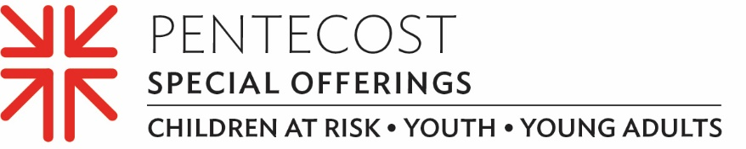

Young Adult Volunteers stand up to injustice and work for healing
As a student at Presbyterian-related Davidson College, Langley Hoyt knew her own mind. The lifelong Presbyterian ventured beyond the college’s bucolic campus into the streets of West Charlotte, N.C., where the world’s injustices were all too apparent.
“For two summers during college, I worked and lived in a neighborhood in Charlotte where my neighbors were mostly Black with low incomes and were very affected by systemic racism, over-policing and the housing crisis,” Langley said. “Because I wanted to keep engaging in these issues of justice while remaining deeply rooted both in faith and community, I was drawn after college to the Young Adult Volunteer program.”
The Young Adult Volunteer (YAV) program is an ecumenical, faith-based year of service for young people ages 19–30 in sites across the United States and around the world. YAVs accompany local agencies working to address the root causes of poverty and reconciliation while exploring the meaning of their Christian faith and accountability to their neighbors in the community.
Because of Langley’s formative summer experiences interning with a nonprofit that advocates for affordable housing, she asked that her YAV placement be with the PC(USA)’s Office of Public Witness in Washington, D.C.
Langley said that her YAV year in Washington, D.C., reinforced the importance of her faith. She continues to discern how she wants “to live and be in the world,” particularly in the light of the PC(USA)’s Matthew 25 invitation to “build congregational vitality, dismantle structural racism and eradicate systemic poverty.”
It was the Matthew 25 initiative that guided much of her work during her year of service with the Office of Public Witness and as she pursues a future as an ordained minister.
“I worked on researching the Presbyterian Church's legacy of white supremacy,” she said. “I believe the church body still has much to do to face its complicity in white supremacy, anti-Blackness and taking some more risks to keep changing course.”
YAVs are supported, in part, through the Pentecost Offering, one of the PC(USA)’s four Special Offerings. Forty percent of the Pentecost Offering is retained by our congregation for local ministries and community grant-making, while the remaining 60% is used to support children-at-risk, youth and young adults through ministries of the Presbyterian Mission Agency.
Together, we are building a life of faith and building the household of God with our children, youth and young adults. As every building needs a strong foundation, each of us needs a foundation in faith that is strong enough to last a lifetime. Please give generously.
Let us pray~
Teach us, O God, in every generation, to offer ourselves in service to your justice and peace. May we learn with and from our children, youth and young adults as we build your house, together. Amen.

