Haiti and Afghanistan Peace & Global Witness Update
As congregations receive the Peace & Global Witness Offering on Oct. 3, we recognize they do so with many concerns on their hearts for our siblings around the world. The devastating earthquake in Haiti and the refugee crisis following the end of the war in Afghanistan are humanitarian disasters of particular concern. Congregations understandably feel called to support relief efforts for these impacted communities.
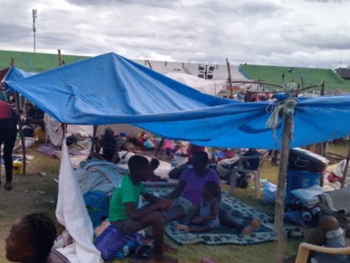
The Peace & Global Witness Offering offers flexibility for congregations to support these relief efforts while supporting the peacemaking work of their mid councils and the PC(USA). Twenty-five percent of the Offering stays with the congregation to support peacemaking and reconciliation in your own community. This year, if your congregation is so moved, we encourage you to contribute your portion of the Offering to assist in either or both Haiti or Afghanistan.
In Haiti, Presbyterian Disaster Assistance (PDA) is providing emergency relief and short-term recovery through our established local partners and in collaboration with ACT Alliance, a worldwide network of Protestant and Orthodox churches. The PC(USA), through PDA, will remain active throughout the entire recovery process, accompanying our partners in the area as they determine long-term program needs and providing financial support for rebuilding and resilience.
A photo of Haitians affected by Saturday’s 7.2-magnitude earthquake.
(Photo by Julio Forges of FONDAMA)
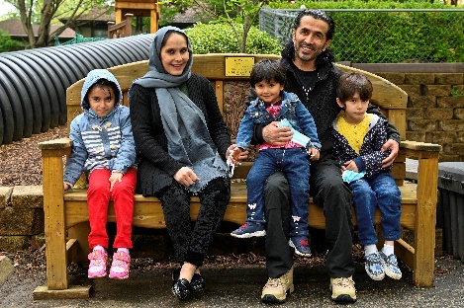
Regarding assistance for our Afghan refugee siblings, PDA is working alongside U.S. resettlement networks and congregations as they welcome the large number of refugees and work to accompany them with both financial and emotional support for a sustainable new beginning. For Afghans who flee to neighboring countries, PDA is working with partners in the ACT Alliance alongside local and regional authorities to respond to the growing needs in host countries like Pakistan and Turkey. PDA is providing financial support for these ecumenical and interfaith efforts.
The Amiri family, recent refugees from Afghanistan, shown on the playground at Second Presbyterian Church in Louisville, Kentucky. The church co-sponsored the family with Kentucky Refugee Ministries for their first months in the United States.
Where there is no justice, there is no peace. This year, we invite you to share God’s peace with our Afghan and Haitian neighbors in particular through the Peace & Global Witness Offering.
Prayer:
Dear God, be with our siblings in Haiti and Afghanistan. Let us answer with our prayers. Let us answer with generous gifts. Let us join together, an international community of healing, to rebuild, restore and in time, rejoice. Remind us that in a world that suffers, light still shines, and darkness and dust shall not overcome it. Amen.

