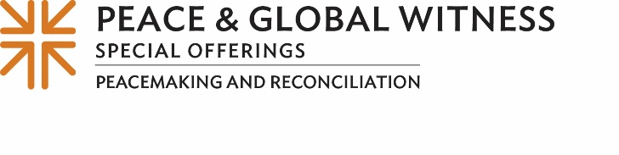
Minute for Mission
Seeking Reconciliation on the Road
While traveling across the American Southwest last spring, Kathy Mitchell was caught by surprise by the stories of her fellow travelers.
“Everybody has a story,” said Kathy, a Native American ruling elder at Trinity Presbyterian Church in Chinle, Arizona, in the heart of the Navajo Nation. “Everybody deserves to be heard.”
Kathy’s desire to share peace and seek reconciliation — both “with those parts of yourself and who you are called to be” as well as through others along life’s journey — unfolded on the road from Albuquerque, New Mexico, to Phoenix during a travel study seminar hosted in 2023 by the Presbyterian Peacemaking Program.
The “Native Lands of the Southwest: The Doctrine of Discovery and its Legacy Today” Travel Study Seminar was a collaborative effort with the Presbytery of Santa Fe and the Synod of the Southwest.
The seminar included opportunities for participants to visit historic sites, hear about Native American experiences and interact with PC(USA) Native American churches to understand the implications of the Doctrine of Discovery, which gave Christian European governments the religious and legal justification to claim lands occupied by Indigenous peoples.
The seminar is made possible, in part, by gifts to the Peace & Global Witness Offering. Traditionally received on World Communion Sunday, which this year falls on Oct. 6, the Offering is unique in that half of it is directed to peacemaking and global witness efforts at the national church level to address critical issues around the world. Twenty-five percent is retained by our congregation for our own peace and reconciliation work, and 25% goes to mid councils for similar ministries on the regional level. (TALK ABOUT HOW YOUR CONGREGATION AND MINISTRIES HAVE USED THE OFFERING)
One congregation deeply committed to the healing and repair of Indigenous nations and communities — thanks to two of its members who participated in the seminar — is Second Presbyterian Church of Richmond, Virginia.
“Living in Virginia and having never visited the Northern Plains states, we learned a great deal about the Indigenous nations in that area,” said Lucretia McCulley and her husband, Dan Ream. “The opportunity that the seminar offered for us to have conversations about history with Native Americans made this trip ideal for us.”
Not long after they returned to Richmond, Lucretia and Dan gave a presentation to their congregation about their life-changing experiences with the travel study seminar. As a result, Second Presbyterian approved a large gift to help with necessary repairs and improvements at Native American churches and chapels.
“We are committed to sharing our gifts that will help address systems of conflict and injustice in the world,” they said. “We also need to live out the denomination’s commitment to peace and justice in our communities and across the world. Small and large contributions to the Offering work together to make significant changes for peace.”

Please give what you can to the Peace & Global Witness Offering — for when we all do a little, it adds up to a lot.

Let us pray ~
God of Every Nation, we thank you for the gift of diversity, and we commit to a future where all people, equal in your sight, are treated as equal in our world. Bless us by your Holy Spirit to be agents of change as we work to live out your reign in this place today and every day. In your Son’s name, we pray. Amen.

