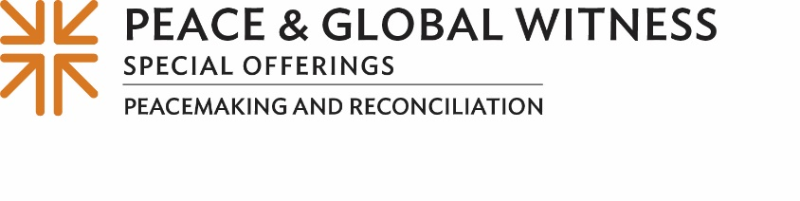
Minute for Mission
Ministering to Migrants on the Brink of Despair
The plight of the thousands of migrants in her native El Salvador keeps Carmen Elena Díaz awake at night.
“Knowing their experiences, their stories, and in ministering to the migrant people, my life has been transformed,” said Carmen. “Their stories mark you, transform you, sensitize you. They make you realize what a hard and difficult subject this is.”
Carmen helps coordinate the Reformed Church of El Salvador’s (IRCES) migrant ministry with deported and displaced people. Addressing the terror and pain of migrants in a country characterized by high rates of violence, political volatility, high unemployment and escalating poverty entails looking not only at immediate solutions but also at other root causes that have led so many in El Salvador to flee their homeland.
Joseph Russ, Presbyterian World Mission’s coordinator for migration issues, advocacy and mission in the Northern Triangle of Central America, which includes El Salvador, Honduras and Guatemala, first came to El Salvador in 2016 as a young adult. Now he works in close partnership with Carmen and her colleagues and is dedicated to offering leadership training in nonviolence and investing in peacemaking to help reduce migration.
Through a shelter program for internally displaced people and returnees — run in collaboration with the International Red Cross Committee — IRCES reduced people’s exposure to violence and poverty and helped them find stability amid difficult and even dangerous situations. In addition, through community farming programs, they support sustainable agriculture efforts for families, so they have healthier food as well as the opportunity to generate income.
Such efforts are made possible, in part, by gifts to the Peace & Global Witness Offering. The Offering is unique in that half of it is directed to peacemaking and global witness efforts at the national church level to address critical issues around the world, like migration. Twenty-five percent is retained by congregations for our own peace and reconciliation work, and 25% goes to mid councils for similar ministries on the regional level. (TALK ABOUT HOW YOUR CHURCH AND MINISTRIES HAVE USED YOUR PORTION OF THE OFFERING)
The Offering also supported the launch of the Central America Migration Mission Network bringing together organizations from El Salvador, Guatemala, Honduras, México and the United States. The network brings together efforts to address the roots of violence and sow the seeds for peace through social transformation in people’s hearts and minds, in public policy and in local communities.
Supporting such collaborative projects of education and Christian witness as the migration network launch is a hallmark of the Peace & Global Witness Offering.
With our gifts to the Peace & Global Witness Offering, we are helping to make a difference. Please give generously, for if we all do a little, it adds up to a lot.

Let us pray~
O God, you are the bringer of peace. In Jesus, you showed us the way of peace. Bless our efforts to do the work Jesus showed us to do as we bring peace through our mission and ministry, our tithes and our offerings. Amen.

