We can make a Display! Or Bulletin Board! Or (fill in the blank)!
The best place to begin when creating a Special Offerings display/bulletin board/etc., is to go to specialofferings.pcusa.org and click on the Offering you are working with. Browse the Resources section by scrolling down.
Great idea-starters from the Resources section could be:
- Posters
- Bulletin inserts
- Minutes for Mission
- Promotional images
- PowerPoint slides
Once you choose a theme:
- Measure the display area (case, bulletin board, window, etc.).
- Make a list of materials you will need.
- Purchase/gather needed materials (see “Shopping/Gathering List” below).
- Select and print offering-related promotional images at: specialofferings.pcusa.org/resource/pgw21-graphics-social-media-images
- or the PowerPoint slides:
  - specialofferings.pcusa.org/resource/pgw21-powerpoint-slides-169
- specialofferings.pcusa.org/resource/pgw21-powerpoint-slides-43
- or choose images from another source of your choice.

Peace & Global Witness Display 2021
Presbyterian Church (U.S.A.) display case
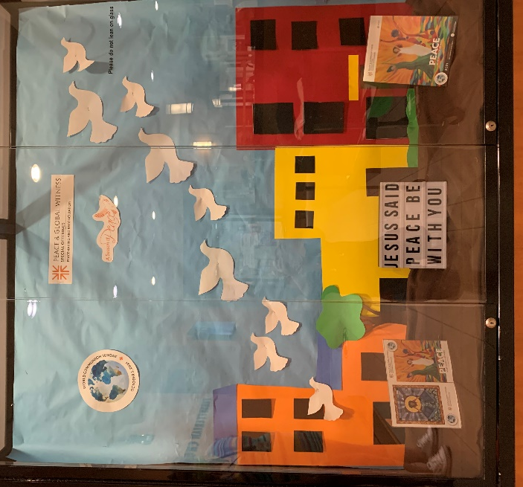

Basic Steps of the Process:
- Create a background for the display. You may have a neutral background already, or you may need to use large sheets of paper.
- If you have a display case, add a coordinating fabric in the bottom.
- Create buildings using posterboard. (We didn’t use templates.)
- Print and cut out peace doves. (We found a graphic on Google Images and printed two sizes.)
- Print all graphics to be used.
- Add P&GW resource samples or other related materials to the bottom of the display or table.
- Mount all pieces to the back of the display/bulletin board.

Shopping/Gathering List:
- For the bottom of the display case:
  - Fabric (we used brown)
  - P&GW Resources
  - Other elements if desired
- For the display wall:
  - Colored background paper (we used blue)
  - Posterboard in a variety of colors
  - Peace dove images (we used nine)
  - P&GW logo
  - A Season of Peace image
  - World Communion Sunday image
  - Stapler
  - Tape
  - Scissors
Not using a display case?
- This project will translate well onto a basic bulletin board. You will need to mount any additional materials that would be in the bottom of a display case, or use the floor space in front of the board.
***If you find another way to create a Peace & Global Witness display for your congregation, please share images with us so we can share them on our social media! Email pictures to special.offerings@pcusa.org.

