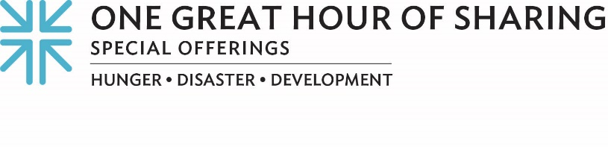
BUILDING CONNECTIONS TO LAST … Advocating for Environmental Justice

What does July 16 mean to you? If you are part of the Navajo nation, or have connections near Church Rock, New Mexico, that date might stir a heartbreaking memory of a preventable disaster that continues to have disastrous impacts.

Over 40 years ago, the earthen dam of a nuclear waste disposal pond broke near Church Rock and dumped tons of solid, radioactive waste and 90 million gallons of acidic and radioactive liquids into the Rio Puerco. The resulting contamination of the land, air and ground water affected nine Navajo municipalities.

The toxic and cumulative effects of this human-caused disaster have impacted the Navajo people for generations — especially in the form of such chronic health problems as asthma as well as a higher incidence of miscarriages, birth defects, and liver and pancreatic cancer. Each year, hundreds of Diné families and their allies come together near the tragic anniversary to pray, to heal and to act, together.

One Great Hour of Sharing connects us with these families through MASE, the Multicultural Alliance for a Safe Environment. MASE’s mission envisions respectful, peaceful communities cherishing a healthy environment.

I like to think that’s a lot like our Church’s mission, too. It is part of what led the Committee on the Self-Development of People to connect with MASE, reaching out “like the arms of the Church,” as the Rev. Dr. Alonzo Johnson with SDOP puts it, to address the systems and structures that perpetuate oppression, leading to poverty.

Susan Gordon, MASE’s coordinator, reminds us that “this is not short-term work. This is decades. And generations. Taking the long view has not prevented progress; the community took a very strong stand opposing new uranium mines on Navajo Nation and were instrumental in getting Navajo Nation to pass two fundamental laws. One prohibits new uranium mining and another prohibits the transportation of radioactive materials across the nation.”

Uranium Legacy Action and Remembrance Day (July 16) connects the importance of lament, especially in the face of an intergenerational trauma, with the opportunity to educate and expose Navajo youth to the realities of environmental racism.

Today I am grateful for Diné neighbors, Gordon, and Johnson, for this church, and the Whole Church, together, for reminding us that this day and every day are part of the decades and generations where we seek change.

Our gifts to One Great Hour of Sharing connect us with people finding their voice and accessing their God-given power, and is the single, largest way that Presbyterians come together to work for a better world by advancing the causes of justice, resilience and sustainability. During Lent, we celebrate that God connects with us through Jesus’ resurrection and connects us with those “who have the least” — that’s how Matthew 25 puts it — and that’s what One Great Hour of Sharing is all about.

Thank you for your generosity! For as we always say … when we all do a little, it adds up to a lot.

Let us pray:
Thank you, God for connecting us. Thank you for neighbors, each with needs and gifts to share, and for our church, the whole Church, together, and for Jesus Christ, Amen.

