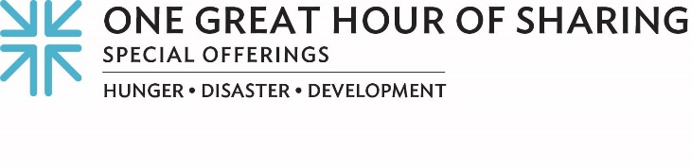
‘Unstable Connection …’
Those two words have taken on a deeper meaning in the past couple of years, haven’t they? For many, the words “unstable connection,” “weak connection” or worse, “lost connection,” are synonymous for an online meeting that has become frozen or dropped off. These dreaded words, popping up on a phone or computer, mean whatever is being offered isn’t getting through. It isn’t able to be shared. The connection is in jeopardy.
But simply stated, we fundamentally need to connect. People need to connect.
Through our Church, we connect, in whatever way we are able, with one another, and celebrate the many ways God connects with us. During Lent, we celebrate that God connects with us through Jesus’ resurrection and connects us with “those who have least” — that’s how Matthew 25 puts it — and that’s what One Great Hour of Sharing (OGHS) is all about. Connecting. People who experience oppression, need, loss or lack, those are the people Jesus connected with, the Bible says, and they are the people we are invited to connect with today.
OGHS is the largest way Presbyterians connect with one another, and with our neighbors in need. We join with people whose connections are, too often, unstable; people experiencing poverty, oppression, hunger and disaster. The Church offers gifts of prayer, understanding and support, by participating in ministries of poverty alleviation and natural and human-caused disaster relief, as well as self-development to ensure dignity for all.
Because of our gifts to OGHS, we connect with the Multicultural Alliance for a Safe Environment in Albuquerque, New Mexico. Together we unite to halt environmental degradation and its impact on the people of the Navajo Nation by assisting in a collaborative effort to secure access to clean water — and thus address the large numbers of birth defects, miscarriages and types of cancer impacting our neighbors there.

We connect with the Resource Center in Matamoros at the southern border of the United States who accompanies our neighbors who are seeking asylum due to economic problems, violence and corruption. Together, we share food, tents and blankets as well as a place for refugees to have access to legal teams, medical teams and social support services.

OGHS connects us with the Civil Society Coalition for Poverty Eradication in Northern Nigeria, where cycles of conflict and food insecurity have been a tragic reality.

For over 70 years, the offerings of thousands of congregations like ours have come together to participate in God’s healing, tending and growing to create a world where all needs are met. Through One Great Hour of Sharing … we stabilize, we strengthen those who are weak, we connect.

Please give generously, for when we all do a little, it adds up to a lot.

Let us pray:
Heal us, oh Savior, that we might understand and grow our relationships with all those in need. Thank you for connecting us with one another and with you. Amen.

