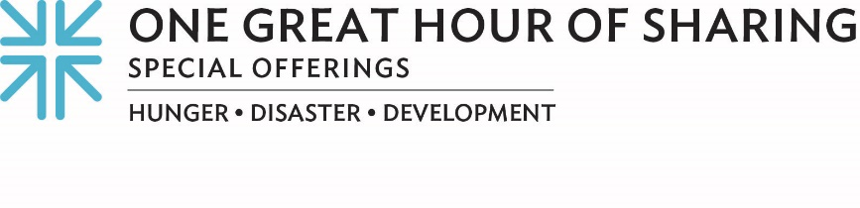
STRENGTH THROUGH CONNECTIONS … Bringing the Promise of Life to the Border

As if coping with the pandemic wasn’t difficult enough, last year pummeled native Venezuelan Paola M. and her family with devastating news. Her father was diagnosed with a rare type of stomach cancer for which a high-risk surgery was needed.

She says, “This news really brought us down because we didn’t have the necessary financial resources, plus, the socio-political situation in Venezuela didn’t allow us to access public health institutions for my father’s treatment.” A desperate internet search resulted in a name, Gabriela Zavala, and when Paola connected with Gaby, it made all the difference.

Paola said, “I was able to contact Gaby [Zavala] and explain the situation we were going through. She guided me by giving me some options, among them the option of immigrating to the United States where they could perform my father’s medical treatment.”

Gabriela, founder and president of the Asylum Seeker Network of Support, is also director of Resource Center Matamoros, a grassroots effort that has provided direct humanitarian aid to thousands of asylum seekers in Mexico. Gabriela and her team — many of whom were asylum seekers and refugees themselves — serve as caseworkers for families like Paola’s, providing them with access to legal, medical and social support services.

Although their decision to seek entry into the U.S. was by no means an easy one, Paola saw it as their only choice. It entailed tremendous sacrifice, loss and struggle to make their way to Mexico to literally save her father’s life.

Paola’s family is just one of thousands who make treacherous journeys in search of help and hope. Each time we share welcome with the stranger, we connect with the 90 Scripture passages including Jesus’ own words in Matthew 25. Susan Krehbiel, who works with Presbyterian Disaster Assistance helping congregations connect with and support refugees, is impressed by the witness to Matthew 25. “It is at the core of the Resource Center mission to welcome the stranger, feed the hungry, clothe the naked and provide human connection,” she says.

As the needs at the border continue to escalate, Gabriela is grateful for the generous gifts of Presbyterians, which help the Resource Center maintain its presence. She says, “A lot of times if it weren’t for us, people would not have the resources they need to escape dangerous situations.”

And I am grateful for Paola, Gabrielle, Susan and all of you as well.

One Great Hour of Sharing is the single, largest way that Presbyterians come together to work for a better world by advancing the causes of justice, resilience and sustainability. During Lent, we celebrate that God connects with us through Jesus’ resurrection and connects us with those “who have the least” — that’s how Matthew 25 puts it — and that’s what One Great Hour of Sharing is all about.

Thank you for your generosity! For as we always say … when we all do a little, it adds up to a lot.

Let us pray ~
Thank you, God, for each relationship you call us into. Thank you for neighbors, each with needs and gifts to share. Thank you for this church, the whole Church, together, and for Jesus Christ, Amen.

