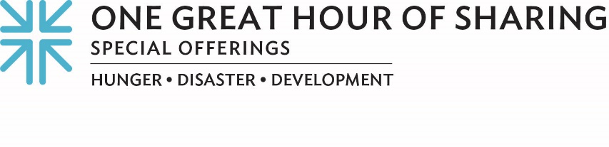
MAKING PROGRESS THROUGH OUR CONNECTIONS …

Imagine living in a wealthy country, working, as a family to survive and still feeling like help never finds you. Unfortunately, many of us understand that experience all too well.

Ohel Swade (O-HELL SWAH-DAE), a farmer living in northeastern Nigeria, shares that experience.
The 52-year-old says, “I do nothing more than farming and my wife does petty trading so our family can eat. We live in a place where help never finds us.” And that is despite Nigeria’s annual ranking among Africa’s wealthiest nations.

Peter Michael Egwudah (EGG-WOO-DAH), program coordinator for the Civil Society Coalition for Poverty Eradication (CISCOPE), says, “Even though Nigeria is one of the wealthiest, oil-producing countries in the world with an abundance of natural resources, the money doesn’t go where it needs to go, to the people.”

Together, we as the Church seek to address poverty with our neighbors here in (NAME YOUR COMMUNITY) and with our neighbors in places like Nigeria. Our gifts to One Great Hour of Sharing connect us with our siblings in Nigeria through CISCOPE as they serve Nigeria’s most vulnerable populations, especially women, by acting as an agent of change.

Peter goes on to say, “The people need something right now, like food and seeds, but we also need to get communities to a place where they can become agents of their own self development. We can train them in new agricultural techniques. We can also help amplify the voice of women to ensure they get a good return when they bring their produce to market. Whenever we go to communities, we always ask ourselves, what can we do to add value. We don’t want to just distribute food, but also equip them to help with their God-given plans.”

And that’s something we in our Church value as well. Valéry Nodem, who works with the Presbyterian Hunger Program, says, “Working with CISCOPE has been inspiring because they are addressing the root causes. They are looking at short, medium and long-term development, working toward the Matthew 25 goal of eradicating systemic poverty.”

Peter says, “I thank the Presbyterian Church from the bottom of my heart on behalf of the people in the communities where we help because it is not easy for anybody to give a dollar to somebody that they have no relationship with. It speaks volumes about our humanity as a people.”

And I would thank Peter, and Valery, and the Swade family, and all of you as well.

One Great Hour of Sharing connects us all and is the single, LARGEST way that Presbyterians come together to work for a better world, advancing the causes of justice, resilience and sustainability. During Lent, we celebrate that God connects with us through Jesus’ resurrection and connects us with those “who have the least” — that’s how Matthew 25 puts it — and that’s what One Great Hour of Sharing is all about.

Thank you for your generosity! For as we always say … when we all do a little, it adds up to a lot.

Let us pray~
Thank you, God, for each relationship you call us into. Thank you for neighbors, each with needs and gifts to share. Thank you for this church, the whole Church, together, and for Jesus Christ, Amen.

