We can make a Display! Or Bulletin Board! Or (fill in the blank)!
The best place to begin when creating a Special Offerings display/bulletin board/etc. is to go to specialofferings.pcusa.org and click on the Offering you are working with. Browse the Resources section by scrolling down.
Great idea-starters from the Resources section could be:
- Posters
- Bulletin Inserts
- Minutes for Mission
- Promotional Images
- PowerPoint slides
OGHS Display 2022 – Gracie the Fish
Presbyterian Church (U.S.A.) display case
Here are a few of our inspiration images:
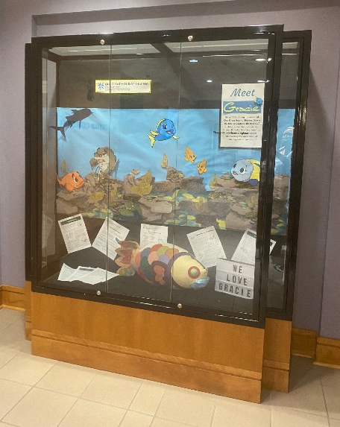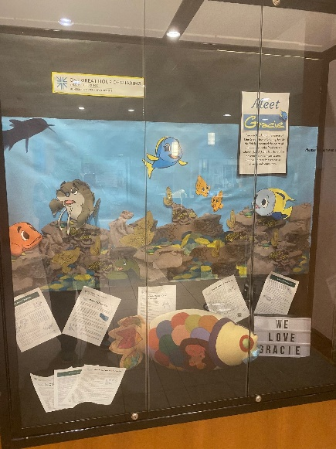
Finished display

Once you choose a theme:
- Measure the display area (case, bulletin board, window, etc.).
- Make a list of materials you will need.
- Purchase/gather needed materials (see “Shopping/Gathering list” below).
- Select and print offering-related promotional images at: https://specialofferings.pcusa.org/resource/oghs22-graphics-social-media/
- or the PowerPoint slides:
- https://specialofferings.pcusa.org/resource/og22-powerpoint-43/
- https://specialofferings.pcusa.org/resource/og22-powerpoint-169/
- or choose images from another source of your choice.
- Create a background for the display. You may have a neutral background already, or you may need to use large sheets of paper.
- If you have a display case, add a coordinating fabric in the bottom.
- Add OGHS resource samples or other related materials to the bottom of the display or table. Palm branches and/or a plate and chalice/cup would work great.
- Mount all pieces to the back of the display/bulletin board.

To make our 2022 OGHS display, featuring Gracie the Fish:
  - We used images from the 2018 Gracie story. If you would like to use these images, find them here.
    - Blow the images up and print them out on 11x17 paper
    - Cut out the parts you want to use
    - Tape them together to resemble the bottom of the ocean
  - Print and cut out OGHS logo
  - Cut background paper to the size of your display area
  - Create underwater scene with Gracie and friends
  - Put fabric in bottom of display case (if applicable), and add resources
Shopping/Gathering List:
- For the bottom of the display case:
  - Black fabric
  - OGHS Resources, including Gracie
  - Other elements if desired
- For the display wall:
  - Colored background paper (we used blue for water)
  - Cut out images of Gracie and friends, and underwater elements
  - OGHS logo
  - Stapler
  - Tape
  - Scissors
Not using a display case?
- This project will translate well onto a basic bulletin board. You will need to mount any additional materials that would be in the bottom of a display case, or use the floor space in front of the board.
***If you find another way to create an OGHS display for your congregation, please share images with us so we can share them on our social media! Email pictures to special.offerings@pcusa.org.

