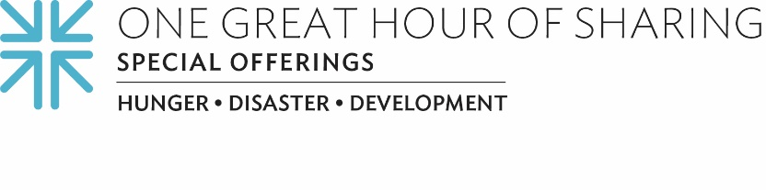
Because We Are the Church, Together
Life during COVID has been challenging. That feels like an understatement, right? At times, we have all felt disconnected, confined. Missing family, missing friends. Lonely. Worried about the groceries holding out. Unsure of what the future may hold. Imagine feeling all of those things but living in a place or in a situation that was already challenging each and every day without the added pressure of the pandemic. A place where access to food is day to day. Access to vital health care is questionable. Finding clean water is a daily struggle. A place where you are denied racial justice or plagued with outright violence and oppression.
But one thing remains steadfast and true: We are the Church, together, no matter where we are, and the Church belongs with those struggling for justice, righteousness and peace for life.
Because food is life … gifts to One Great Hour of Sharing are helping the people of Pine Ridge Indian Reservation in South Dakota through a partnership with Owe Aku — a grassroots, nonprofit organization that puts people in charge of their own food supply, nutrition, health and well-being by reclaiming ancestral wisdom and teaching Lakota history and culture. The Pine Ridge Reservation is a food desert, located in the county with the lowest per capita income in the nation. The pandemic has dramatically amplified the desperate need for food security.
Because water is life … gifts to One Great Hour of Sharing are helping the families of Capirendita in a remote area of Bolivia face a more hopeful future by building infrastructure to address the communities’ critical water shortage. Their goal is to create 500 meters of pipes to transport safe well water to those in need. One Great Hour of Sharing gifts will also support the distribution of plastic containers to collect and save rainwater.
Because survivors are key to shaping lives focused on justice for all … gifts to One Great Hour of Sharing are helping Black Women’s Blueprint in its mission to take action on social justice issues and to deliver educational resources and support services to women, including those who have suffered sexual and other forms of abuse. Their work seeks to address the unique struggles of Black women and girls within the context of the larger racial justice concerns. They’re not just addressing issues of trauma but they’re also providing things like food and housing assistance that people need in order to be whole.
The Special Offerings of the PC(USA), including One Great Hour of Sharing, offer the whole Church a way to embody Matthew 25 through the Spirit-inspired stories and gifts that place us in service and partnership with those who have least. Our gifts directly support people experiencing hunger, homelessness, thirst, imprisonment, sickness and deprivation, as well as welcoming the stranger. One Great Hour of Sharing is the largest way that Presbyterians come together in mission and ministry with those whom we see are in need.
Because we are the Church, together … we give to One Great Hour of Sharing because of where the Church belongs, of who the church is. Please give generously so that our Church will continue to become, as Isaiah said, “repairers of the breach.” And as we always say: When we all do a little, it adds up to a lot.

Let us pray~
God of life, be with us. May we see you in the lives of all we meet, and may we offer ourselves in kindness and kinship to all those in need. Amen.

