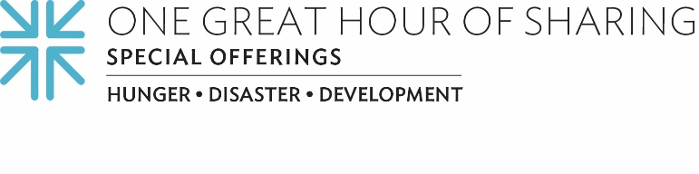
Because Water is Life
When Manuel Nazario casts his net into the water these days, his catch is far less plentiful.
In the remote area of Bolivia near the Paraguay-Argentina border, Manuel and the members of his indigenous community are finding that fishing, their traditional livelihood, is now in severe jeopardy.
The Capirendita (pronounced CAP-IR-EN-DITA) community is grappling with the devastating impact of climate change, irregular rainfall patterns, prolonged droughts, disease and mining pollution. As a result, their age-old ways of life and their means of economic support are increasingly threatened. The degradation of the environment and the mounting lack of access to water threatens their very survival.
Manuel has emerged as one of the leaders in his fishing community. A born innovator and community organizer, he is now leading the families in Capirendita toward the promise of a better way, in partnership with a local organization called CERDET (Center for Regional Studies of Tarija). Together they are working to develop irrigation systems and to collect and store rainwater for safe drinking.
Because of gifts received through One Great Hour of Sharing, like the gifts you and I will make to this Offering here in our congregation, CERDET is building infrastructure to address the communities’ critical water shortage. Their goal is to create 500 meters of pipes to transport safe well water to those in need. Manuel will be responsible for carrying out the excavation work on the underground piping system. Our gifts will also support the distribution of plastic containers to collect and save rainwater.
One Great Hour of Sharing helps us address critical water needs in places like South Sudan, training technicians to dig water wells for their communities and on maintenance, hygiene and sanitation. And in places like Detroit, our gifts have joined We the People of Detroit to secure access to water for those who might otherwise have had their water shut off during the pandemic. Imagine not being able to wash anything during the pandemic!
One Great Hour of Sharing is the single, largest way that Presbyterians come together every year to share God’s love by becoming “repairers of the breach,” joining with people in need to build God’s house, together. Together we are making a better world for those in need no matter where they are. Please give generously, for when we all do a little — it adds up to a lot.

Let us pray ~
Meet all the needs for which the world thirsts, O God. May your spring of justice, compassion and peace spring up quickly, and may it spring up quickly in us. Amen.

