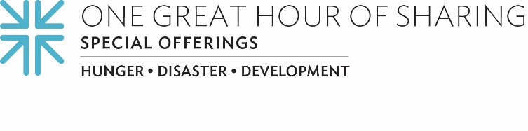
Because Healing Empowers
“Mama O” is a survivor, a healer.
Her moment of greatest need led her to Black Women’s Blueprint, a civil and human rights organization headquartered in Brooklyn, New York. Since 2008, Black Women’s Blueprint is specifically focused on the needs of Black women and girls. At 65 years of age, Mama O is among the eldest survivors of sexual violence in the organization.
Despite living with the lifelong trauma that results from sexual violence, Mama O is a pillar of strength for other survivors, both young and old. Our One Great Hour of Sharing gifts are helping Black Women’s Blueprint in its vital mission to take action on social justice issues and to deliver educational resources and support services to women like Mama O. Through their work, they seek to address the unique struggles of Black women and girls within the context of the larger racial justice concerns of Black communities.
“Through all of Mama O’s ups and downs, she returns to community, holistically and ever-present,” said Sevonna M. Brown, the organization’s associate executive director. “She has continued to contribute creative healing arts and spiritual intercessory prayer on behalf of our survivor communities, carrying us through transitions, challenges and triumphs.”
The Rev. Alonzo Johnson, coordinator for the Presbyterian Committee on the Self-Development of People, the organization’s partner, says, “Despite the challenges of the ongoing pandemic, Black Women’s Blueprint continues to be out in the community addressing issues of trauma and providing things like food and housing assistance that people need in order to be whole.”

Mama O is just one example among the many women who now bless and lift up others, an ongoing benefit of the organization’s partnership with the PC(USA), for which Brown is especially grateful.

“We want to share our gratitude for the continued leadership that the One Great Hour of Sharing and Self-Development of People partnerships have shown over the years,” said Brown. “We are hopeful that times will grow brighter, and that we will come out on the other side of this with more wisdom, care, compassion and strategies for healing our communities and walking hand in hand towards a future of greater possibilities and opportunities to center survivors as the key to community thriving and justice.”

Thanks to our gifts to One Great Hour of Sharing, programs like Black Women’s Blueprint are lifting up women just like Mama O. Every gift makes a difference in the life of someone who deserves God’s love and support; someone who deserves our love and support. We are the Church, together. And when we all do a little, it adds up to a lot.

Let us pray ~
May our healing spring up quickly, as the prophet Isaiah proclaims. May these gifts, God our physician, be a balm and medication for your people and your world. Amen.

