Make a Bulletin Board! Or a Display! Or (fill in the blank)!
The best place to begin when creating a Special Offerings display/bulletin board/etc., is to visit our website for inspiration – pcusa.org/christmasjoy. There are posters, promotional images and PowerPoint slides to spark your creativity!
Christmas Joy Offering Display 2023 – The Perfect Gift
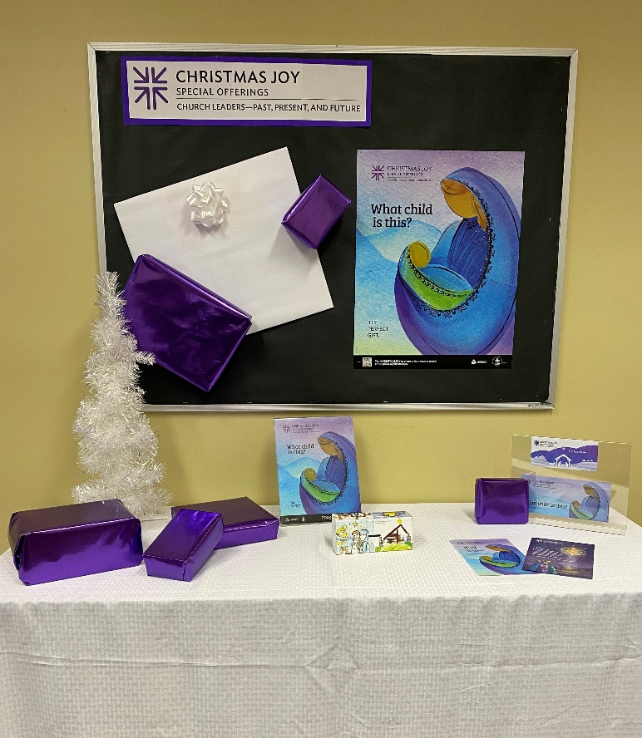
To create a display similar to this one:
- Mount paper to a bulletin board or display area. We used a black paper background to make the colors of the poster pop!
- Cover the table with whatever fabric you choose. We used a white tablecloth.
- Print the Christmas Joy logo found on the Resources page of the Christmas Joy website and mount it on the bulletin board.
- Wrap boxes of various sizes with colorful wrapping paper.
- Wrap one larger, flatter box in white to represent “the perfect gift.”
- Arrange the logo, Christmas Joy poster, a couple of other gifts and the white gift on the bulletin board.
- Place Christmas Joy resources and the rest of the gifts on the table below the bulletin board.
- We had a small white Christmas tree on hand, so we added it!

Shopping/Gathering List:
- For the table:
  - Fabric/tablecloth
  - Christmas Joy resources — order them here, or use the samples from your leader’s packet or print from our website.
  - Wrapped boxes as gifts
  - Optional: Add a Christmas tree or some other item you have on hand that connects consciously to the season.
- For display wall:
  - Background paper
  - Wrapped white gift
  - Smaller wrapped gifts
  - Christmas Joy logo
  - Poster

***If you create a different version of a Christmas Joy Offering display, we would love to see pictures! With your permission, we would share them on our social media sites! Email pictures to special.offerings@pcusa.org. If you have trouble accessing resources, or have questions about any component of this display, please reach out to the email address above or call 800-728-7228, ext. 5047.

