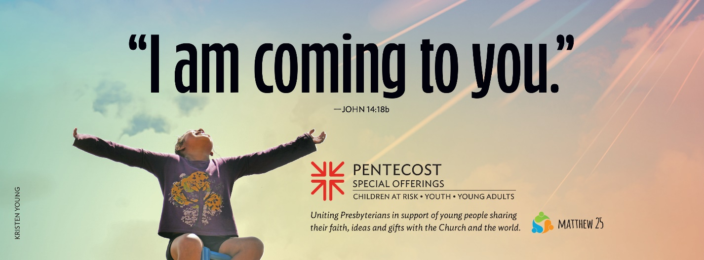

2024 Children’s Lesson
April 1–May 19

Goals and Purpose
- Children will hear the promise that Jesus gave his friends that he would not leave them alone and find it fulfilled in the story of Pentecost.
- Children will consider how the Holy Spirit comforts, counsels, connects and encourages us as we grow in faith.
- Children will celebrate the gift of the Holy Spirit!

Supplies
- copies of Pentecost Story Pictures (pre-cut for younger children) and one copy for the storyteller (both a color copy and a black/white copy are provided, and either will work)
- copies of The Story of Pentecost Script for each child
- scissors
- sandwich bags or paper bags
- game supplies (depending on your choices: small balls or beanbags, pencils/paper)

Optional Supplies — depending on your activity choices for Celebrate the Holy Spirit
- birthday party prep materials (decoration supplies, cookie/cake decorating supplies, birthday candles, matches)
- straws, cotton balls, tissue paper balls or ping pong balls, plastic cups
- paper or copies of the flame story circle, mural paper, tape, markers, blindfold
- extra-long ribbon or ball of yarn (red if possible)
- 2- to 3-foot lengths of ribbon/streamers/yarn per child
- elastic circles (rubber bands/hair ties)
- copies of the Pentecost Coloring Sheet for each child
- crayons, colored pencils or markers (especially red, orange and yellow)
- red, orange, yellow and white strips of paper, 1 inch by 6 inches, markers, tape or stapler

Gathering (5–10 minutes)
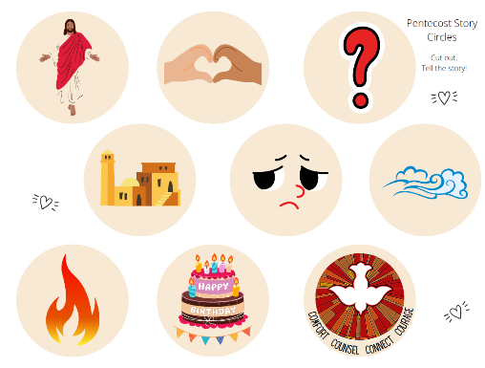
As your group gathers, give each child a copy of the Pentecost Story Circles and invite them to cut the circles out. Have them place their circles in a sandwich bag or paper bag and label it with their name. You might have older children help younger ones or have the circles pre-cut for young children and invite them to color or decorate their bag as a gathering activity. Set the bags with the circles aside until later.

When the group has gathered, give each child the instructions and/or materials needed to play a simple, familiar game, but tell them they must spread out around the room and play it alone — by themselves. For example, you might give them a small ball or beanbag and tell them to play Catch; pencil and paper to play Tic-Tac-Toe; or ask them to play something like Rock-Paper-Scissors or I Spy by themselves. Some may insist they can’t do it alone; encourage them to try. Others might make up a different kind of game. If they begin to team up to play something together, let that happen. After a few minutes (if they haven’t already), ask them to team up with someone else to play together.

After a few minutes of play, call the group back together and ask:
- What was difficult about playing your game alone?
- How was it better playing with someone else?
- Besides games like these, what other times can be better when you are with a friend?

Using your own words, say something like:
“Sometimes we like playing or being alone. Other times, we need friends around us. Today we are going to learn about a friend that is always with us — a friend that Jesus promised us.”

Hearing the Bible Story (5 minutes)

Gather the group to hear the story, and give children their copies of the Pentecost Story Circles. Use your own copy of the Pentecost Story Circles as you tell the story, placing the corresponding circle down so that children can see it and follow along with their own circles. (See The Story of Pentecost Script for the same words with the accompanying picture circles.)

The Story of Pentecost

Before he died and rose again, when Jesus knew the time was coming when he would go away, he told his disciples something important. (lay down the Jesus circle)

“When I’m gone, you won’t be all alone. God will send a friend, a helper, a comforter to be with you forever. (add the Friends/Heart circle) The Holy Spirit will be with you. I am going away, and also, I am coming to you.”

The disciples didn’t know what to think. (add the Question circle) And so much happened after Jesus said those words that they almost forgot. But later, after Jesus had died, had risen again and then had gone away, they remembered. It happened like this.

On the day of Pentecost, they were in Jerusalem. (add the Jerusalem circle) They were all together in one room, feeling sad and sort of afraid. (add the Sad Face circle) Jesus was gone. But suddenly, into the room and into each of them, came the Holy Spirit! In a rush, with what felt like wind (add the Wind circle) and looked like fire (add the Fire circle), the Spirit of God changed everything.

It was the birthday, the very first day of the church! (add the Birthday circle)

The disciples remembered what Jesus had said — I am coming to you. The Holy Spirit was the friend he had promised. (add the Pentecost circle)

(Rearrange the circles into a C shape and trace the shape as you say …)

The Spirit comforted them (trace the C shape) when they were sad or afraid.
The Spirit counseled them (trace the C shape) to follow the way of Jesus.
The Spirit connected them (trace the C shape) to each other in love and faith.
The Spirit gave them courage (trace the C shape) to share the good news about Jesus.

Exploring the Story (5 minutes)

Share with the children a little bit about a friend you have — how they comfort, counsel and encourage you; ways you connect; why they matter to you. Invite the children to share about a friend of theirs. If you have a large group, pair the children up to share about a friend with a partner. A smaller group can do this all together. Give a prompt like, “My friend matters to me because …” Embrace an expansive understanding of “friend” to include pets or teens/adults who are friends.

Say something like:

A good friend can bring out the best in us. They can comfort us when we are sad. They can counsel us when we wonder how to live or act. They remind us that we are connected, and not alone. They can encourage us when we need it and give us courage to be our best selves in the world.

The Holy Spirit does all those things, too. The Spirit is a comforter when we are upset or sad and a counselor who guides us. The Spirit connects us to God and to one another. And the Spirit gives us courage and encourages us to grow in faith and to share love, peace, joy and justice in the world. So, today, we celebrate the Holy Spirit!

Give children a copy of The Story of Pentecost Script to add to their Pentecost Story Circle bags so they can retell the story at home.
Celebrate the Holy Spirit! (20–40 minutes)

Choose from the following activities to further explore and celebrate the Holy Spirit. Think ahead about any adaptations you can make for group members with particular needs.

- Plan a Birthday Party for the Church.
You may be using this lesson plan on or near Pentecost Sunday. Or, you may be using it at another time in the church year. Either way, conversation about birthdays and celebrating is always appropriate! Just like we celebrate growing a year older with a birthday party, we celebrate the birthday of the church at Pentecost. And we celebrate any day and every day how the Spirit helps us keep growing in faith.
Talk about what you might need for a birthday party (decorations, invitations, friends/family, snacks and cake, presents, etc.). Let the children self-select which of these they might work on and encourage their creativity as they craft invitations and decorations, play Pentecost/birthday games (see below for ideas) or decorate cupcakes/cookies to enjoy. Be sure to sing “Happy Birthday” to the church, and blow out birthday candles (wind and flames together)!
As you plan and prepare for the celebration, wonder together:

- What gifts can you offer the church?
- Where do you see the Holy Spirit working in our community of faith?
- When do you feel the Spirit with you?
- When has the Spirit given you the courage to try something new?
- How has your faith grown since your last birthday?

- Play Pentecost/Birthday Games.
- The Wind of the Spirit:
Give each child a straw. Line up at the end of a table. Take turns blowing a cotton ball, tissue paper ball or ping pong ball into a cup at the end of the table. Variations on this game can include team or relay competitions or adding more balls.

- Pin the Flame on the Disciples:
Make extra copies of the Pentecost Story Circle with the flame, enough for one per child. Or invite children to make their own cut-out of a flame shape. Trace the outline of a child on a piece of mural paper and post it on a wall. Share that when the Holy Spirit blew into the room where the disciples were gathered, it looked like the flames rested on each disciple. In turn, blindfold children and have them pin/tape their flame on the disciple outline. Afterward, you might have the children add words or pictures to the outline showing how they might use their hands, feet, legs, arms and heads as the Holy Spirit helps them love God, their neighbor and the world.

- Pentecost Memory Game:
Use two copies of the Pentecost Story Circles to play a memory game in pairs. Give each pair of children copies of the circles and have them place them in a grid face down. Take turns turning over two circles. If they match, they keep the pair and go again. If they don’t match, turn them back over, and the next person takes a turn. Challenge them to share something about any pair they gather. What does it have to do with the story of Pentecost?

- Spirit Celebrating with Ribbon or Yarn.
- Play a game of Spirit Connections. Have children stand in a circle, then toss a ball of yarn across to another player, naming something that connects them. For example, “we both like singing” or “we go to school together.” As they catch the yarn, they should unravel it a bit, then hold on to or loosely loop it around their wrist before tossing it to another person. Point out the web of connections that we share because the Spirit has brought us together.

- Make Spirit Streamers.
Tie 2- to 3-foot-long lengths of ribbon, crepe paper streamers or multiple lengths of yarn to an elastic rubber band or hair tie. You can use the streamers in several ways:
  - Try making shapes in the air: animals, favorite foods, tracing letters.
  - Make shapes or flutter the ribbon as you dance, skip or jump.
  - Move to music or retell the Pentecost story with streamers.
  - Make up a game to play with the streamers.
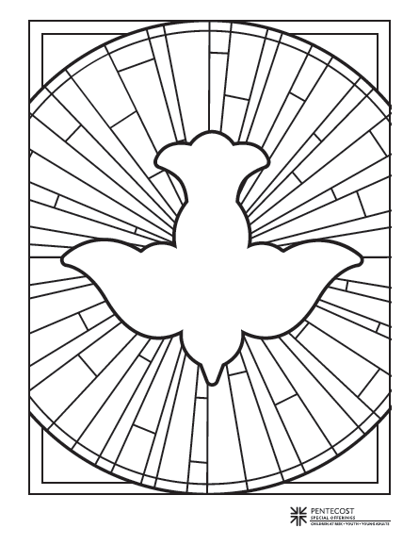
- Use the Pentecost Coloring Sheet for Pentecost Prayers.
Give each child a copy of the Pentecost Coloring Sheet. Explain that the Holy Spirit is sometimes pictured as a dove, like people saw when Jesus was baptized. Other symbols for the Spirit include flames, fire, wind or breath. Talk together about how the Holy Spirit connects us to one another, and to all God’s children. Invite the children to write the names of people to whom they are connected by the Holy Spirit in spaces on the coloring sheet.

- Use a red pencil or crayon to add the names of family members.
- Use an orange pencil or crayon to add the names of friends.
- Use a yellow pencil or crayon to add the names of each other, and others in the church.
- Use any other color to add anyone else to whom they are connected in faith.

Talk about how coloring with names like this can be a way to pray for people. As we color, we think about them, give thanks for them, and pray that they may feel God’s love and ours.

- Make a Holy Spirit Chain.
Connect red, orange, yellow and white strips of paper as you talk about how the Spirit helps us grow in faith. Using the words and ideas from the story (how the Holy Spirit Comforts, Counsels, Connects and gives us Courage), invite children to write or draw on the strips, then attach them to a long chain using tape or staples. Hang the strip in your classroom space, or use it to start a group art installation about the Holy Spirit. Invite others in the church to add to it!
- On a red strip, write or draw a time when someone comforted you, or you comforted someone else.
- On an orange strip, write or draw a time when someone gave you good advice or counsel, or you gave the same to someone else.
- On a yellow strip, write or draw a time when you felt connected to someone in faith.
- On a white strip, write or draw a time when you had courage or encouraged someone.

- Plan ahead to celebrate the gifts of young people and the Pentecost Offering!

Explain that the Pentecost Offering your congregation collects helps young people just like them grow in faith.
- Forty percent will stay in your local congregation or region.
- Sixty percent will help with denominational projects like the “Educate a Child, Transform the World” national initiative, and support for the Office of Presbyterian Youth and Triennium and the Young Adult Volunteer Program.

Do a little advance planning and research through the links above to connect these projects in your context. Where has the Pentecost Offering gone in past years, and how can you share that information with your class? Do the youth in your church attend Triennium or a Presbyterian Youth Conference? Have them come and share about it. Can you connect with a YAV or a former YAV to have them come and speak to your class? Can a young person in your congregation come and share about their faith, and where they see/feel the Holy Spirit in their life and in the church? How can your class help gather the offering this year, and encourage your congregation to give?

Closing Prayer Practice (5 minutes)

Explain that in Hebrew, the word for God’s spirit (ru’ah) is also the word for “breath.” We often think of the Holy Spirit as wind or breath, and we can notice them all even when they are invisible to the eye. Together, practice some simple breath prayers for when you want to focus on the Spirit’s comfort and care. Demonstrate how to say or think the words quietly as you breathe in and out slowly:

- Holy Spirit (breathe in), be with me (breathe out).
- Breath of God (breathe in), live in me (breathe out).
- Holy Spirit (breathe in), comfort me, or counsel/encourage/challenge me (breathe out).
- Spirit, Friend (breathe in), help me grow (breathe out).
- What words would the children use?

Send home the Story Circle bags, the Pentecost Story Script and information about how to participate in your congregation’s Pentecost Offering!
More Ways to Extend the Learning

Tell the Pentecost Story at Home
Use your Pentecost Story Circles and Script to tell the story to someone else. Talk together about how the Spirit comforts, counsels, connects and encourages you.

Holy Spirit Kindness Game
Make a Pentecost symbol backed with something sturdy, like cardboard. Use the Pentecost Coloring Sheet dove, or one of the Pentecost Story Circles for inspiration. During the week, take turns doing an act of kindness for someone else at home. Make their bed or a special snack, do one of their chores or leave a kind note for them, but do it secretly! Leave the Pentecost symbol behind as a way to pass on the Spirit. That person then gets to share the next act of kindness and the symbol for someone else.

Practice Breath Prayers
See instructions under Closing Prayer Practice above.

Celebrate the Spirit as you fly a kite, blow bubbles, spin in circles or notice the wind!

Prepared by the Rev. Julie Coffman Hester. Julie is a pastor and writer in North Carolina who has served all ages in faith formation for over 30 years. Her current ministry focuses on writing curriculum and resources, and teaching workshops on writing as a spiritual practice and writing through grief. You can find her at juliehester.com and subscribe to her writing prompts at writingincompany.substack.com.

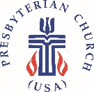

2024 Pentecost Offering Curriculum

