Activities
Isaiah 55:12 (NIV)*
You will go out in joy and be led forth in peace; the mountains and hills will
burst into song before you, and all the trees of the field will clap their hands.

Lesson Objectives: The Peace of God
- Children/families will color pictures of mountains, trees and/or hills.
- Using Isaiah 55:12, children/families will explore joy and peace and places/activities that help us feel joy and peace.
- Children/families will create a collage together.

GATHERING ACTIVITY (15 minutes)

As the children enter the space, say “WELCOME” to each child. Allow children to gather at one table as they enter the space. Have the coloring sheets out with colored pencils and/or crayons. Make sure at least one of each picture is being colored. But generally, allow the children to choose the picture they would like to color.

Say: I would like you to share with us the picture you chose. But before we do that, can someone tell me what joy means? (allow for a few responses). Can anyone share with us a time when you were happy? (allow for a story or two).

- You can also ask “polling” questions/“polling” prompts
  - Raise your hand if you are happy when you get ice cream.
  - How many of you are happy on your birthday?
  - Who has a pet that makes them happy?

Now, allow the children to share the picture they chose with the group. Do this in a manner that works best for everyone in the class.

SCRIPTURE EXPLORATION (30 minutes total)

SAY: Before we explore the Scripture, let’s say a prayer.

Say the prayer below, one of your own or invite one of the children to pray.

Dear God, thank you for our time together. Thank you for our friends. Help us hear your words. Help us learn your love. In the name of Jesus Christ we pray. Amen.

- Read Isaiah 55:12 (NIV) – reading exploration (20 minutes)

You will go out in joy and be led forth in peace; the mountains and hills will
burst into song before you, and all the trees of the field will clap their hands.

Have the children repeat after you as you read the Scripture a second time.
After you have read the Scriptures, ask the following questions and allow the children time to answer:

ASK: How does the Scripture say you will feel? (joy; joyful and peace; peaceful)
ASK: What will sing? (mountains and hills)
ASK: What will the trees do? (clap their hands)
ASK: What can people do when we feel joy? (varied answers)
SAY: Think about a place that you go that makes you so happy. When you find out you are going to this place, you jump for joy. Or you clap your hands like the trees of the field. Or you sing like the mountains and hills. Put that place in your mind. Hold the place in your smart brain. Does everyone have a place in mind? Now, tell us your place. (allow children to respond one by one)
After everyone has shared
SAY: These all sound like really fun places to go happily. When the Scripture says we will go in joy, it means that you feel like you do when you are going to (insert places that the children named). So, God gives us directions, God wants us to do that with the same joy we have when we are going to (named places). We are going to create a “COLLAGE OF JOY”
ACTIVITY: Use magazines, newspapers or catalogs so the children can cut and/or tear out pictures of things that make them joyful or happy. They can also include pictures of people who show a happy face. If there is a large-enough group, then a group can be assigned to create an “ANTI-JOY Collage.” This can be a place where anything that is not joyful is displayed and/or includes people, pets or animals with an unjoyful face.
NOTE: There can be multiple collages created based on the number of children. I would encourage groups of five children or fewer. Collages can be displayed at the end for parents to see.
Play the song “You Shall Go Out With Joy” – singing exploration* (10 minutes)
11. “You Shall Go Out With Joy”: Written by Stuart Dauermann
EXTENSION OPTION
Put the children in groups according to the picture they colored at the beginning of class. Sing through the song again allowing the children to hold up their pictures as their word is being sung.
CLOSING prayer (2 minutes)
Encourage the students to repeat after you as you lead the prayer.
Dear God, please help us to leave joy and peace wherever we go. In the name of Jesus Christ we pray. Amen.
*It is recommended that the teacher read Isaiah 55 for full context.
MOUNTAINS

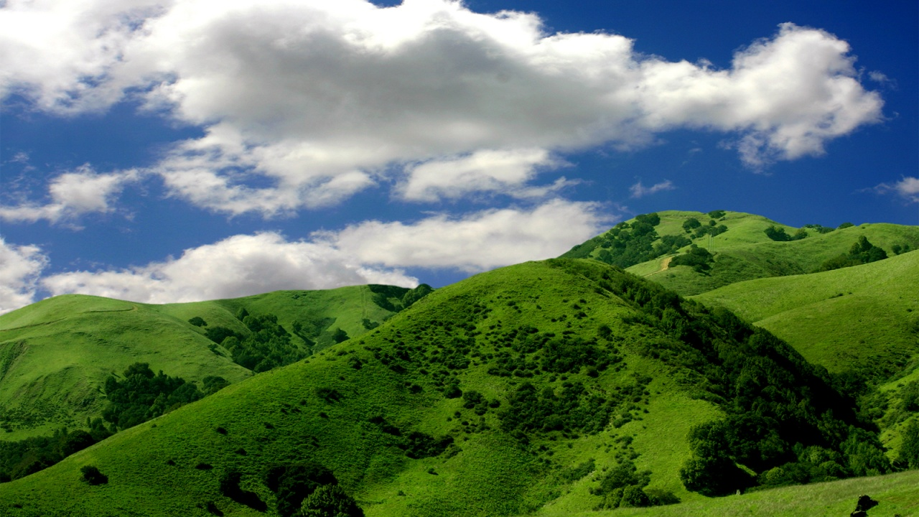
HILLS

Created by — Natarsha Prince Sanders is currently DEdMin student at Columbia Theological Seminary and writing fellow at Collegeville Institute, Collegeville, MN. She is the Executive Director of Centering the Sacred, a ministry that focuses on spiritual development and growth for people of all ages.

