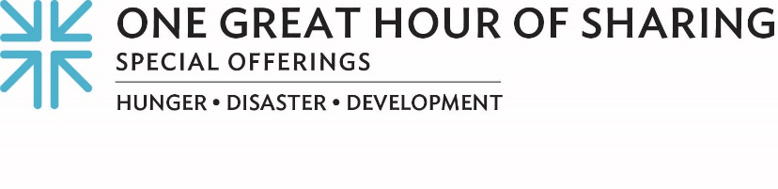
Minute for Mission
‘We saw you’
In all her 66 years, Magda Cruz had never witnessed anything like Hurricane María’s power to destroy. The Category 4 hurricane ravaged the island of Puerto Rico.
Many residents lost large parts of their roofs, so they had to either abandon their homes or sleep in unsafe conditions. Thankfully, Fideicomiso [fee-day-cō-mē-sō], a community land trust supported by gifts to One Great Hour of Sharing, provided a lifeline by building and installing safe roofs throughout the community, which helped Magda’s and many other families sleep more securely.
The persistent and dire conditions in Puerto Rico following Hurricane María continue to impact the island’s most vulnerable communities. Through One Great Hour of Sharing, three Presbyterian Church (U.S.A.) ministries — the Presbyterian Hunger Program, the Presbyterian Committee on the Self-Development of People and Presbyterian Disaster Assistance — have joined hands and resources in response.
Walking alongside those impacted by the hurricane is about long-term community development by eradicating poverty, which is one of the Presbyterian Committee on the Self-Development of People’s core strategies.
“Fideicomiso is all about building capacity to respond to the community in case of emergency,” said Mariolga Juliá Pacheco, Fideicomiso’s director of Citizen Engagement and Social Development. “The last grant we received through the Presbyterian Church helped us to construct roofs for 14 families, and soon we’ll start a new project putting in water tanks. Three schools had to shut down because of the hurricane, so we will be putting solar panels in one of the schools as an alternative energy source for the future.”
She continued, “We have a wide range of social programs and projects that we work on in areas as diverse as environmental affairs, infrastructure, recreational programs for the young, violence prevention, grassroots organizing and support for the elderly. Every project intersects.”
The Presbyterian Hunger Program is especially excited about the water tanks that Fideicomiso is planning for the G-8 headquarters and community center. This life-saving measure will provide sustenance for residents should they be hit by future storms and will create greater community resilience.
Working with Fideicomiso is one of the many ways Presbyterian Disaster Assistance is responding to the Matthew 25 question, “When did we see you?” This partnership answers that question with: We saw you in this community. We saw you in what has been going on for many decades. We saw you in the people asking for justice.
In Isaiah 58, we are called to be repairers of the breach — offering shelter in the face of natural disaster, providing economic support in the face of poverty, and providing food in the face of hunger. For over 70 years, One Great Hour of Sharing has provided Presbyterians a way to respond by sharing God’s love with our neighbors in need around the world.
Please give generously to One Great Hour of Sharing. For as we always say … when we all do a little, it adds up to a lot.

Let us pray~
God of mercy, may your restoring grace and power to repair overwhelm destruction and undo all harm. Make us instruments, through the gifts we make this day, in meeting the needs of those who suffer. Amen.

