We can make a Display! Or Bulletin Board! Or (fill in the blank)!
The best place to begin when creating a Special Offerings display/bulletin board/etc., is to go to specialofferings.pcusa.org and click on the Offering you are working with. Browse the Resources section by scrolling down.
Great idea-starters from the Resources section could be:
- Posters
- Bulletin Inserts
- Minutes for Mission
- Promotional Images
- PowerPoint Slides
- Media Tool Kit

OGHS Display 2024 – Celebrating 75 Years of OGHS!
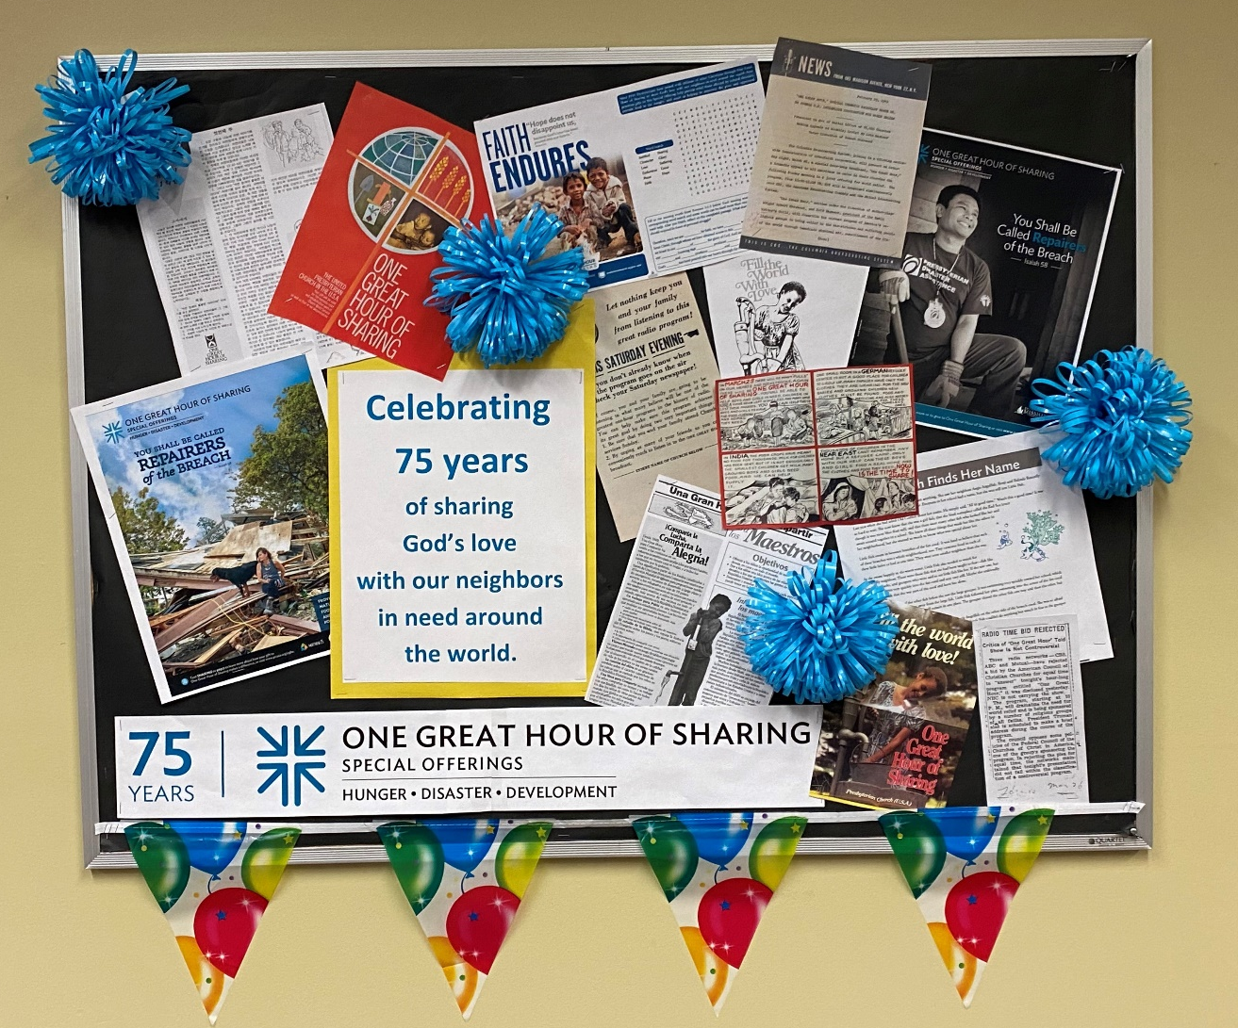
Once you choose a theme:
- Measure the display area (case, bulletin board, window, etc.).
- Make a list of materials you will need.
- Purchase/gather needed materials. Download materials here.
- Create a background for the display. You may have a neutral background already, or you may need to use large sheets of paper.
- If you have a display case, add a coordinating fabric in the bottom.
- Add OGHS resource samples or other related materials to the bottom of the display or table.
- Mount all pieces to the back of the display/bulletin board.

To make our 2024 OGHS display:
We printed and added to the bulletin board:
- OGHS logo
- Ephemera from 75 years of OGHS and celebratory statement
We purchased celebratory items from the party aisle of a discount store, such as a balloon banner and pompoms, and added them to the bulletin board.

If you find another way to create an OGHS display for your congregation, please share images with us so we can share them on our social media! Email pictures to special.offerings@pcusa.org.

