What does a “display” look like in 2021?

While it may seem a little challenging to put up a “display” when your congregation isn’t meeting in your church building, there are many ways you can show your creativity around an Offering, and share with your congregants and the community.

Last year, staff, churches, congregants and communities got imaginative with their Special Offerings displays. Below are examples (for OGHS and others). Folks driving by will see your creations and appreciate you still doing the work of building God’s house, even during these difficult times.

Where Can You Do A “Display?”
- An actual display case or bulletin board in your church building
- Your church window(s) or door(s)
- In front of your church, on the sidewalk, on the parking lot, etc.
- For congregants, in a window, on a door, on the sidewalk, or in your driveway
- Do a virtual display in your e-newsletter, on your website or on social media

Some Ideas to Spark Your Creativity
- Print a prayer on paper and put in a window or on a door
  - Here’s one from a Minute for Mission you can use:

Let us pray ~
May our healing spring up quickly, as the prophet Isaiah proclaims. May these gifts, God our physician, be a balm and medication for your people and your world. Amen.

- Place the OGHS poster in a window or on a door
- Encourage your congregants to print out promotional images for OGHS and put in a window at home
- Encourage your younger members to complete the OGHS coloring page and submit their masterpieces for a virtual art show
- Use sidewalk chalk and create art on the sidewalk, driveway or parking lot
- Use washable paints and create art on a window or door

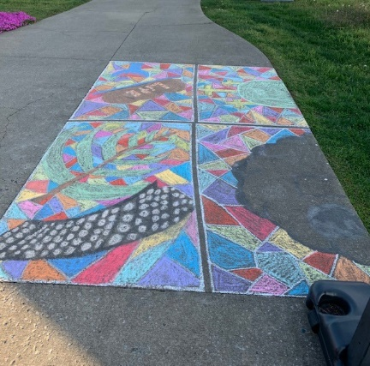
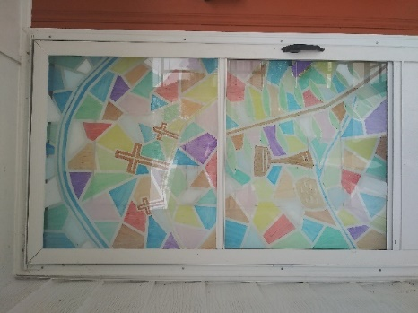
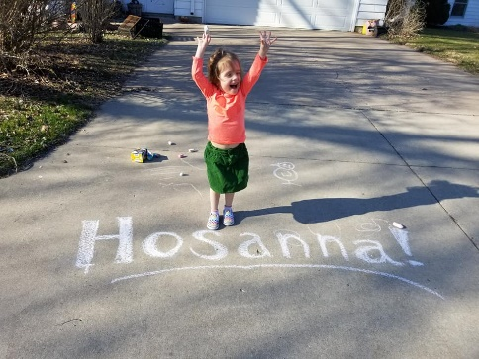

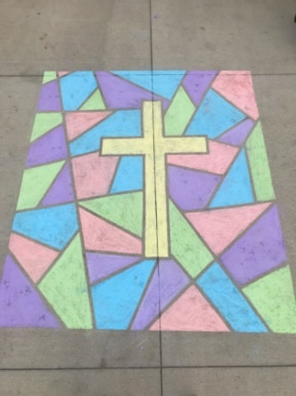

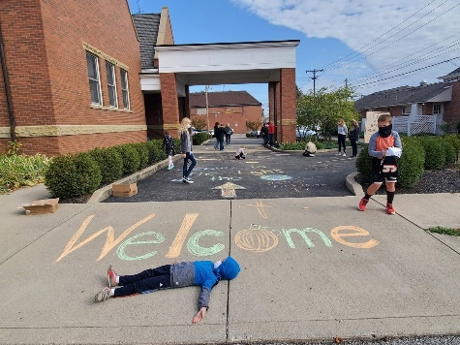

PLEASE SHARE! Take pictures as you create your artwork, then post on social media and tag us!

facebook.com/specialofferings
instagram.com/special_offerings
twitter.com/pcusa_so

Have questions? Call Special Offerings at 800-728-7228, ext. 5047, or email us at special.offerings@pcusa.org.

