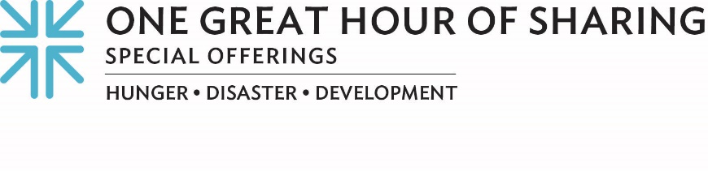
Minute for Mission
Living on the Brink of Disaster
Bernadette thought that she had seen the worst of it.
For well over a decade, she and her family withstood Syria’s ever-worsening humanitarian and economic crisis, the country’s ongoing localized hostilities and its collapsing infrastructure. But following the devastating 7.8-magnitude earthquake that struck Syria and Turkey in February 2023, her own home began crumbling beneath her very feet.
Although most of their neighbors had left the unsafe apartment building to seek safer refuge, Bernadette’s family remained in their home. They simply couldn’t afford to pay the escalating rent costs elsewhere. Living on meager salaries, the family’s income was barely sufficient to meet their basic needs.
In the midst of such dire conditions — families without access to water, shelter, education, medical care and other essential services — the Middle East Council of Churches (MECC) works around the clock to alleviate the suffering of the Syrian people. The humanitarian mission of the Middle East Council of Churches is made possible, in part, through a grant from Presbyterian Disaster Assistance, which is in turn supported by our gifts to One Great Hour of Sharing. The Offering also benefits the ministries of the Presbyterian Hunger Program and Presbyterian Committee on the Self-Development of People.
“Whenever people are unable to secure basic needs, some families adopt negative coping mechanisms, such as reducing meals, resorting to child labor, or, as a last resort, leaving Syria,” said Samer Laham, regional director of Diakonia, the branch of MECC that administers its social, humanitarian and development services programs. “What we do, in cooperation with our partners, is continually seek to support people. We have aided families like Bernadette’s, whose homes were damaged by the earthquake in Aleppo, working to ensure that they live in a stable building where their children can sleep safely.”
Bernadette is grateful that her building could be stabilized and her apartment rehabilitated.
“We offer our thanks to all who have given so generously,” she said. “Our prayers likewise go out to all who stand by us and receive the Offering to ease our economic burdens and encourage us to stay in our country and continue witnessing to our Christian faith.”
Samer laments that whenever there’s a disaster, people are moved very quickly to donate, but once the immediate crisis is over, “not the same money will come.”
“You cannot imagine people in such destitute circumstances,” he said. “Here we can see the suffering and the very critical conditions that many families are facing today. This is why we want to be a sign of hope to many people through One Great Hour of Sharing. In the end, we are working as one team, as one people, to bring hope to affected people. This is part of our faith.”
Please give generously to help those living on the brink. For when we all do a little, it adds up to a lot.

Let us pray~
God of mercy and compassion, we remember all those around the world who face dire living circumstances each day. Be with them and allow our gifts to strengthen and support them in all ways, so that they might live in safety and security. We pray in Jesus' name. Amen.

